AI-POWERED SENTIMENT ANALYSIS SYSTEM
Month 2 Project – Evaluation Report
Natural Language Processing (NLP) and Machine Learning

1. Abstract
This project develops an end-to-end sentiment analysis system that classifies customer reviews into Positive, Negative and Neutral categories. The workflow includes data validation, exploratory data analysis, text normalization, TF-IDF and Bag-of-Words feature extraction, supervised model comparison, grouped cross-validation, hyperparameter tuning, final evaluation and deployment through Streamlit. A tuned Logistic Regression pipeline was selected and serialized for inference.

2. Problem Statement and Objectives
Manually examining thousands of customer reviews is time-consuming. The objective is to automate the classification of review text into three sentiment classes and expose the trained classifier through a simple interactive web application.
- Inspect and clean the supplied review dataset.
- Explore sentiment, category, source and review-length patterns.
- Transform text into numerical features using TF-IDF and Bag of Words.
- Compare Multinomial Naive Bayes, Logistic Regression and Linear SVM.
- Evaluate with accuracy, precision, recall, F1-score, confusion matrix and multiclass ROC-AUC.
- Use group-aware cross-validation and Grid Search to select a final model.
- Save the complete preprocessing-and-classification pipeline and serve it through Streamlit.

3. Dataset Description and Data Quality
The supplied CSV contains 10,000 records and five columns: review_id, review_text, sentiment, category and source. There are no missing values and no exact duplicate rows. The class counts are Positive=3,334, Negative=3,333 and Neutral=3,333.
A critical data-quality observation is that there are only 300 distinct review_text values among 10,000 rows. Thus 9,700 rows repeat a text already present elsewhere. The repeats are not exact duplicate records because review IDs and/or metadata differ. Removing repeated text would discard valid rows and shrink the dataset to only 300 examples, so the original records were retained.
To prevent identical review strings from leaking between partitions, a StratifiedGroupKFold split was used with review_text as the group. This creates an 80% training partition (8,000 rows) and a 20% test partition (2,000 rows), while keeping each distinct text wholly within one partition. The same group-aware principle was used during five-fold cross-validation.
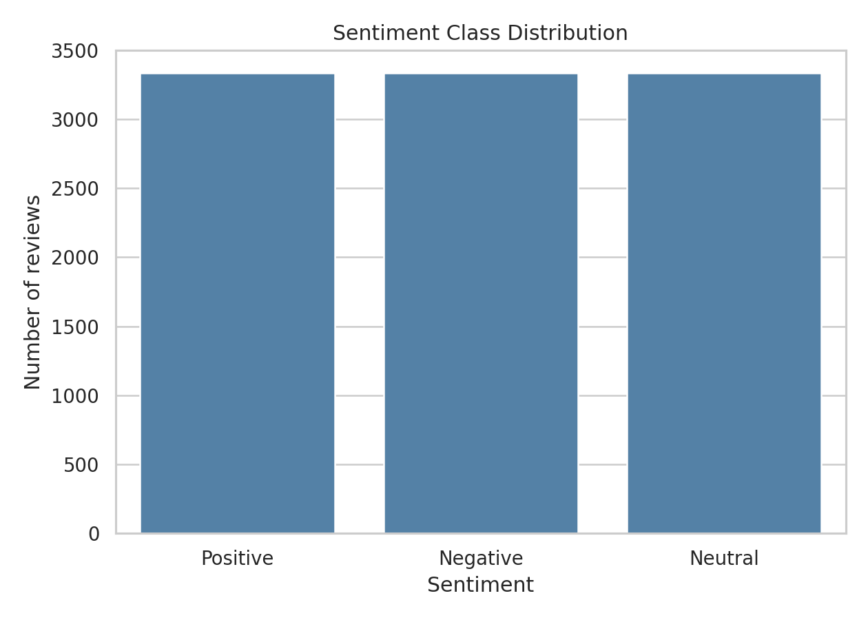
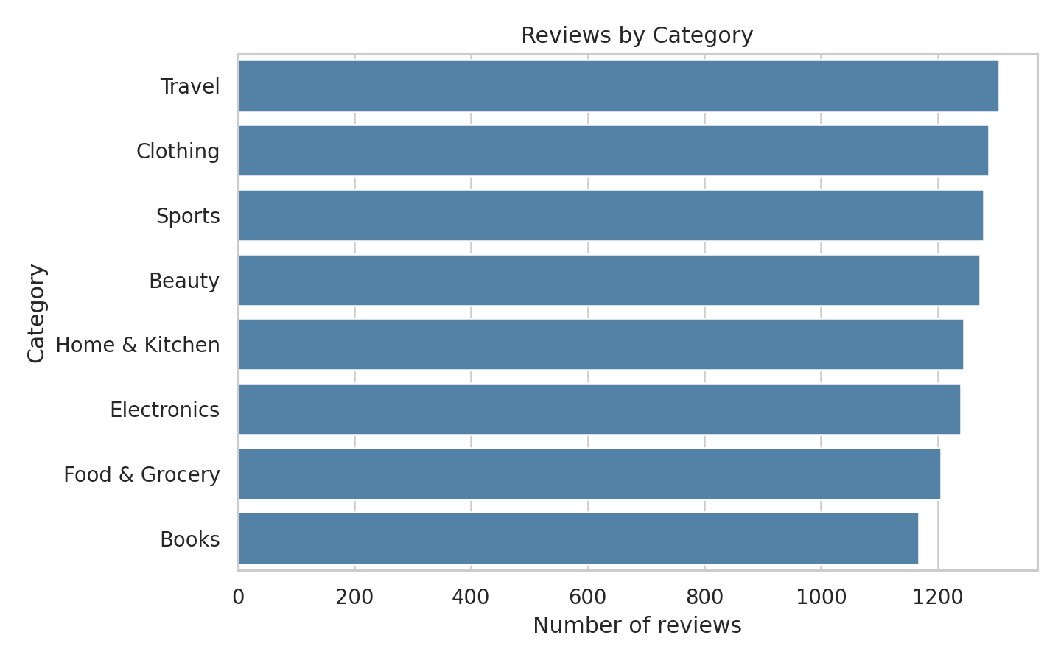
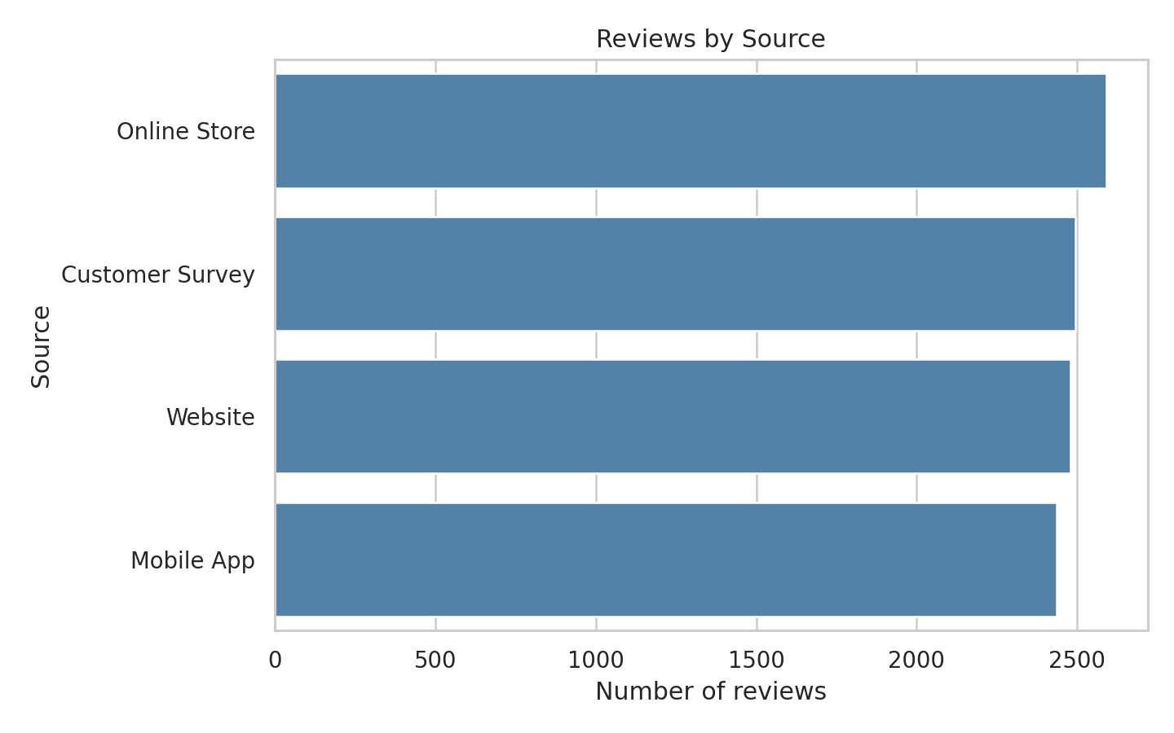

4. Exploratory Data Analysis
The mean review length is 16.30 words and the median is 17 words. The three sentiment classes are almost perfectly balanced, so there is no major class-imbalance issue in the supplied corpus. Category and source counts are visualized in the accompanying EDA figures.
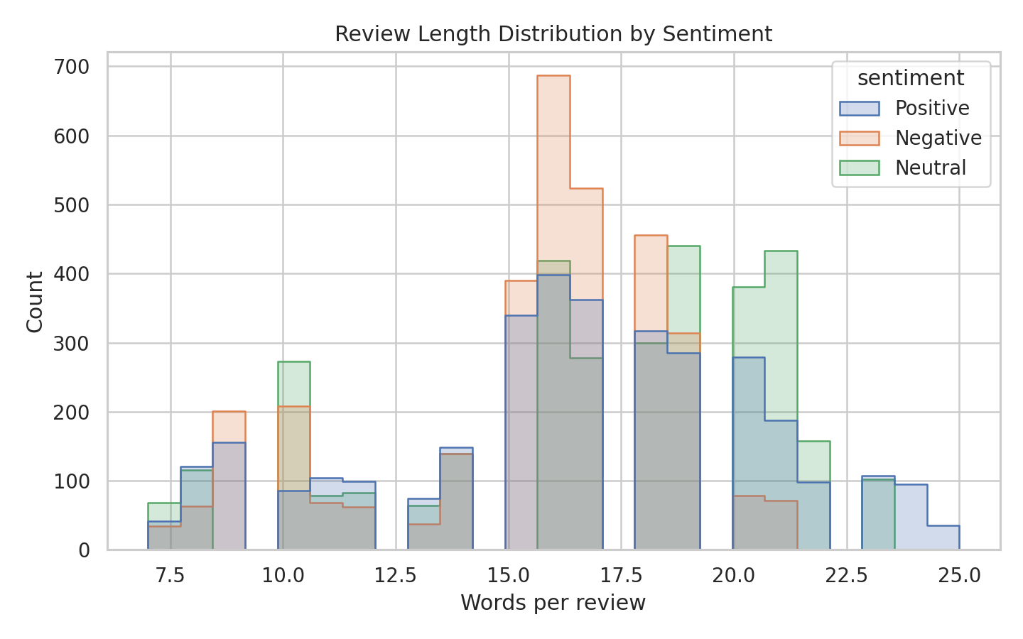

5. Text Preprocessing and Feature Extraction
A conservative normalizer decodes HTML entities, removes HTML tags, replaces URLs with a URL token, converts text to lowercase, removes most punctuation and collapses repeated whitespace. Negation terms such as “not” and “no” are retained because removing them can reverse the meaning of a review. No aggressive stemming or lemmatization is applied.
Bag of Words represents a document by token counts. TF-IDF weights terms according to their frequency in a review and their inverse document frequency across the corpus, reducing the influence of terms that occur in many documents. Both representations were compared within scikit-learn pipelines to prevent vocabulary leakage.

6. Model Training and Comparison
Four baseline configurations were compared on the same grouped holdout set: Multinomial Naive Bayes with TF-IDF, Logistic Regression with TF-IDF, Linear SVM with TF-IDF, and Logistic Regression with Bag of Words. Macro-averaged precision, recall and F1 were reported so each sentiment class contributes equally.
Model | Accuracy | Macro Precision | Macro Recall | Macro F1
MultinomialNB (TF-IDF) | 1.000 | 1.000 | 1.000 | 1.000
Logistic Regression (TF-IDF) | 1.000 | 1.000 | 1.000 | 1.000
Linear SVM (TF-IDF) | 1.000 | 1.000 | 1.000 | 1.000
Logistic Regression (BoW) | 1.000 | 1.000 | 1.000 | 1.000
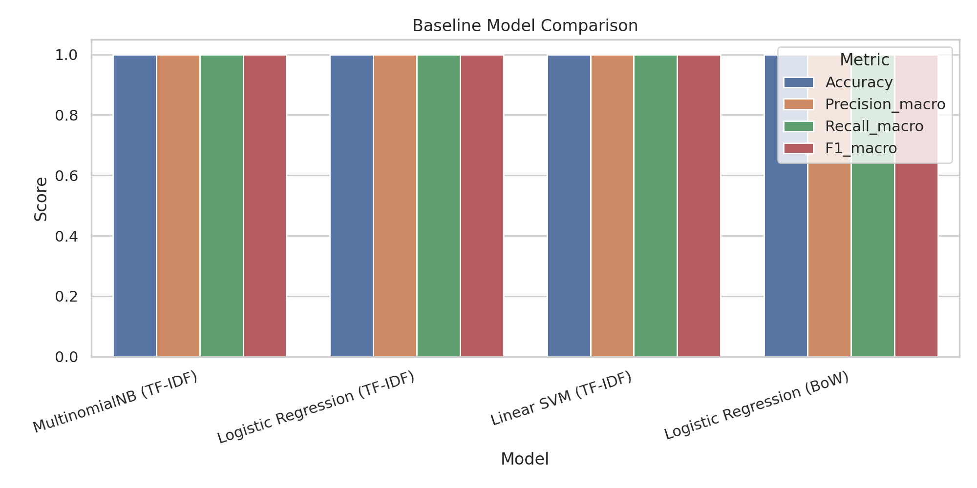

7. Hyperparameter Tuning and Cross-Validation
Logistic Regression with TF-IDF was tuned using GridSearchCV and five-fold StratifiedGroupKFold. The search considered C values 0.5, 1.0 and 2.0; unigram or unigram-plus-bigram features; and min_df values 1 or 2. Macro F1 was used as the selection metric.
Selected parameters: C=0.5, ngram_range=(1, 1), min_df=1. Best cross-validation macro F1 from Grid Search: 0.9964.
Mean five-fold grouped cross-validation metrics: accuracy=0.9964, precision_macro=0.9966, recall_macro=0.9964, f1_macro=0.9964.

8. Final Evaluation
On the untouched 2,000-row grouped test set, the tuned model achieved accuracy=1.0000, macro precision=1.0000, macro recall=1.0000, macro F1=1.0000 and macro one-vs-rest ROC-AUC=1.0000.
Precision measures the proportion of predicted members of a class that are correct. Recall measures the proportion of actual members of a class that are detected. F1 is the harmonic mean of precision and recall. Accuracy is the proportion of all predictions that are correct. The confusion matrix shows actual versus predicted class counts.
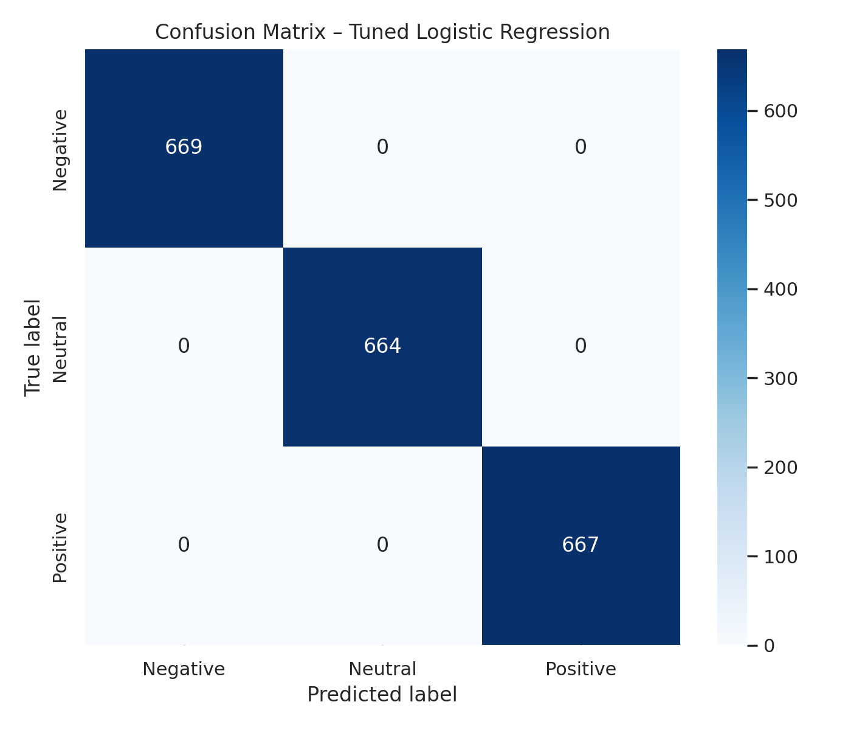
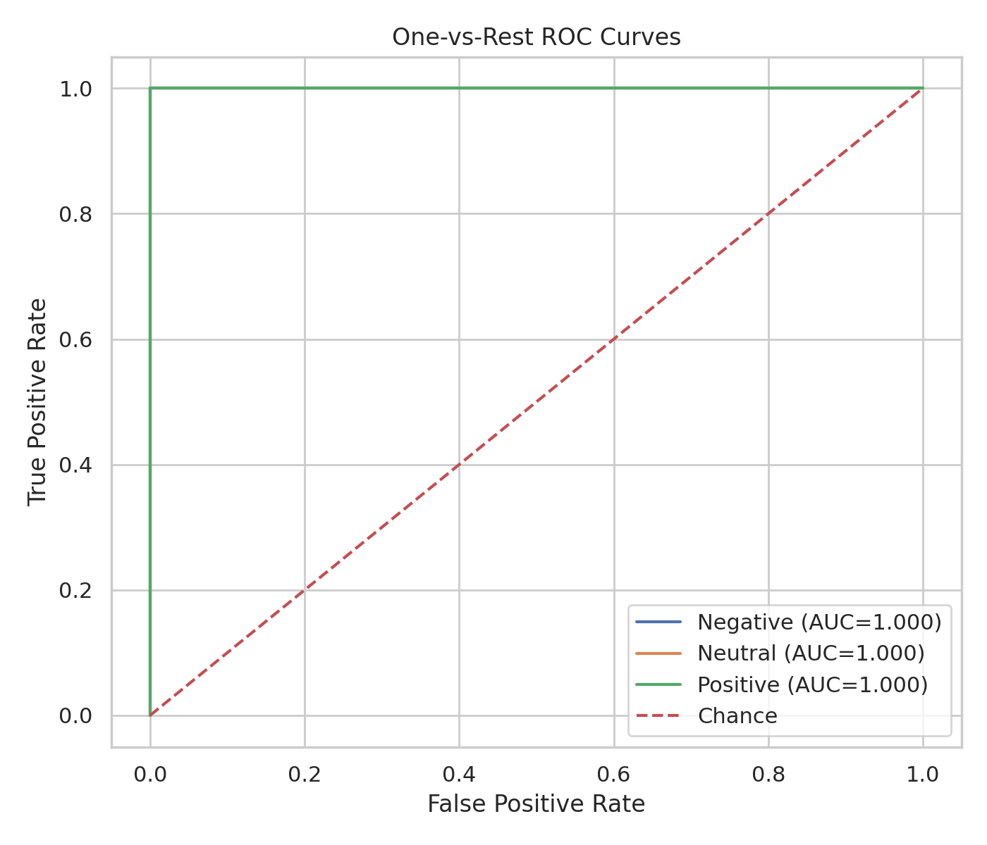

9. Overfitting and Underfitting Analysis
The best Grid Search candidate achieved mean training-fold macro F1=1.0000 and mean validation-fold macro F1=0.9964, giving a gap of 0.0036. This small gap suggests limited overfitting within the grouped folds. It does not prove generalization to external data. The very high holdout score and near-perfect CV score should be interpreted cautiously because the corpus contains only 300 distinct text templates. The evaluation can still be optimistic with respect to real-world language diversity, even though exact text leakage was prevented.
No strong evidence of underfitting is visible on this dataset because training and validation scores are both very high. However, the limited template variety means this conclusion applies only to the supplied corpus.

10. Model Serialization and Streamlit Application
The complete scikit-learn pipeline, including the TF-IDF vectorizer and Logistic Regression classifier, is saved as models/sentiment_pipeline.joblib. The Streamlit application loads the saved pipeline and accepts new review text. It displays the predicted sentiment and the class probability estimates. The model is not retrained when the application starts.
To run the application: install dependencies with pip install -r requirements.txt, then run python train_model.py if the model needs to be rebuilt, and finally execute streamlit run app.py.

11. Conclusion and Future Improvements
The project implements all major stages of a conventional supervised NLP workflow and produces a reusable inference pipeline with a working Streamlit interface. TF-IDF with tuned Logistic Regression is selected for deployment because it provides a compact, interpretable baseline and probability estimates. The measured performance is excellent on the supplied corpus, but it must not be represented as expected performance on arbitrary customer reviews.
Future improvements should prioritize collecting many more independently authored reviews, checking label quality, including spelling variations, sarcasm and mixed sentiment, testing on a genuinely external dataset, calibrating predicted probabilities, and monitoring model performance after deployment.

12. Deliverables
- Python source and reusable text-normalization module
- Jupyter notebook with complete workflow
- Serialized trained model pipeline
- Streamlit prediction application
- requirements.txt and README.md
- Evaluation report and saved plots

